© ABB Limited 2008
This document contains information that is confidential. It must only be used for the agreed purpose for which it is provided. The contents of this document must not be reproduced or distributed in whole or in part without the written consent of ABB Limited or its authorised representatives.

Title | Controller Custom Modbus Commands Frame Description
Distribution | Software Archive
Author | Greg Leach | Date | 2008-11-05
Review |  | Date
Approved |  | Date
Remarks

Contents
1 Introduction 4
2 Components of Modbus frames 4
2.1 Device Identifier 4
2.1.1 Master frame 4
2.1.2 Slave frame 4
2.2 Command Identifier 4
2.2.1 Master frame 4
2.2.2 Slave frame 4
2.3 Data field 5
2.3.1 Master frame 5
2.3.2 Slave frame 5
2.4 Exception code 5
2.4.1 Master frame 5
2.4.2 Slave frame 5
2.5 Checksum 5
2.5.1 Master and slave frame 5
3 Type distribution in the register table 6
4 Custom Modbus commands frame description 8
4.1 Read commands 8
4.1.1 Read eight-bit 9
4.1.2 Read sixteen-bit 10
4.1.3 Read thirty-two-bit 11
4.1.4 Read single-precision floating-point 12
4.1.5 Read double-precision floating-point 12
4.1.6 Read float with units 14
4.1.7 Read string 15
4.1.8 Read diagnostic information 17
4.2 Custom read command exception responses 19
4.3 Write commands 19
4.3.1 Write eight-bit 20
4.3.2 Write sixteen-bit 21
4.3.3 Write thirty-two-bit 22
4.3.4 Write single-precision floating-point 23
4.3.5 Write double-precision floating-point 23
4.3.6 Write float with units 25
4.3.7 Write string 26
4.3.8 Trigger action function 28
4.4 Custom write command exception responses 28
References 29
Revision History 29

List Of Figures
Figure 1 – Single-precision floating-point variable register consumption 6
Figure 2 – Unsigned eight-bit variable distribution in the register table 7
Figure 3 – Float with units variable distribution in the register table 7
Figure 4 - General form of custom read command master request 8
Figure 5 - Slave response to read eight-bit command for four variables from index 30000 9
Figure 6 - Read sixteen-bit response to request to read two variables at index 31000 10
Figure 7 - Slave response to request to read one thirty-two-bit variable at index 34000 11
Figure 8 – Slave response to a read single-precision floating-point command 12
Figure 9 – Slave read double command response 13
Figure 10 – Read float with units slave response 14
Figure 11 – Slave response to master read string request to read two strings 16
Figure 12 – Extended diagnostic information block 17
Figure 13 – Slave response to master request to read two diagnostic information blocks 18
Figure 14 – Modbus exception response frame 19
Figure 15 – General form of a master write request 19
Figure 16 – Slave response to a successful master write request 19
Figure 17 – Master request to write two eight-bit variables starting at location 40000 20
Figure 18 – Master request to write two sixteen-bit variables starting at index 41000 21
Figure 19 – Master write thirty-two-bit request to write one variable at index 44000 22
Figure 20 – Master request to write a single-precision floating-point value at index 45000 23
Figure 21 – Master double-precision float write request 24
Figure 22 – Write float with units request 25
Figure 23 – Master write string request to write two strings 27
Figure 24 – Master request to trigger action objects 28

Introduction

This document describes the frame format required for the Controller Modbus implementation custom commands.
Modbus RTU will be used for the Controller - any further references to protocol frames are with respect to the RTU implementation.

Components of Modbus frames

This section details the component parts used (but not necessarily in all commands) in Modbus protocol frames.

Device Identifier

Each slave device on a Modbus network is assigned a unique identifying code, between 1 and 247 inclusive.

Master frame

The first byte sent by a master during a request is the identifier of the slave device the request is intended for.

Slave frame

When responding, the slave device will send its device identifier as the first byte of its response frame.

Command Identifier

This is a code assigned to a command and indicates to the slave device what kind of action to take. Standard Modbus commands (sometimes referred to as Public Modbus commands) are within the ranges 1 to 64 inclusive, 73 to 99 inclusive and 111 to 127 inclusive.

User-defined commands can be added in the ranges 65 to 72 inclusive and 100 to 110 inclusive. As these commands are device specific, the functionality can never be guaranteed to be the same for two different device types.

Master frame

The single-byte Command Identifier is sent after the Device Identifier.

Slave frame

When responding with no error, the slave device sends the Command Identifier as the second byte in its response.
Should a command not be processed correctly, the device sets the msb of the command code, and sends it as the second byte to indicate an error condition (this is equivalent to binary ORing the command code with 0x80).
For example, should a request for command 0x1 be received and not be carried out correctly by the slave device, the value 0x81 would be returned as the second byte.

Data field

Master frame

Following the Command Identifier, the master sends the data of the request. This can be a number of bytes up to the maximum allowable by a Modbus frame, 252 bytes (allowing for Device Identifier, Command Identifier and Checksum).

Slave frame

Slave devices place the response data to requests from masters here.

Exception code

When commands cannot be carried out correctly by a slave device, an exception code is returned to provide details of the error.

Master frame

Exception codes are only used in slave device responses.

Slave frame

If a slave device cannot process a command, it sends a single-byte exception code following its device identifier and modified command identifier.

Checksum

Master and slave frame

The final two bytes of a Modbus frame consist of the sixteen-bit CRC of the content of the message, from Device Identifier through to the final byte of the Data Field inclusive.

Type distribution in the register table

Variables accessed using custom commands reside in the minimum number of registers to accommodate the size of that variable. For example, a single-precision floating-point variable resides in two registers. Figure 1 illustrates this.

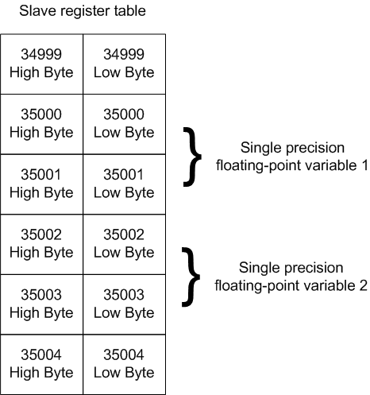

Figure 1 – Single-precision floating-point variable register consumption

If a single-precision floating-point variable were to reside at index 35000, the next would reside at 35002. Attempting to read the register at 35001 would return an error-code as this is the third byte of the single- precision floating-point variable that starts at register 35000.

Figure 2 and Figure 3 show how eight-bit and float with unit variables are distributed in the register table. If these registers are read with standard Modbus commands, the unused bytes are set to 0x0 before being sent.
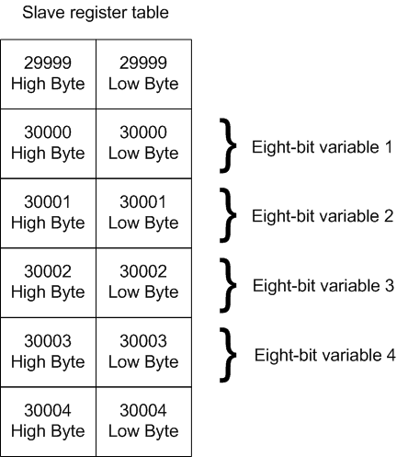

Figure 2 – Unsigned eight-bit variable distribution in the register table

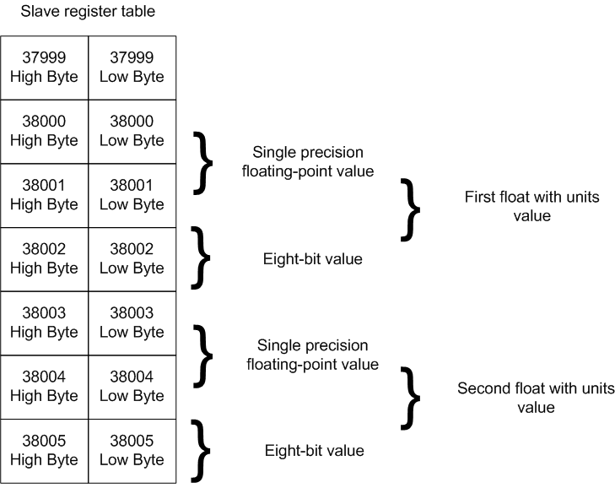

Figure 3 – Float with units variable distribution in the register table

Custom Modbus commands frame description

The following sections give details of the custom commands defined in the Controller Modbus subsystem requirements specification.

Read commands

The general form of the custom read command request is shown in Figure 4. All of the custom commands described in the following section follow this format for the master request.

Figure 4 - General form of custom read command master request

When the master requests to read multiple variables, all must be of the same type, and the addresses at which they reside must be contiguous in the register table.

A distinction should be made here between standard Modbus commands, and the custom commands. Standard Modbus commands issue the number of registers to be read – these are always sixteen bits in length. In the case of the custom Modbus commands, the master issues the number of variables to be read. This will be four bytes per single-precision floating-point variable being read, or eight bytes per double- precision floating-point variable, etc.

Read eight-bit

Master request

This command allows one or more eight-bit variables to be read from a slave device. After the device and command identifiers, the master sends a two-byte register address from where to commence reading data, followed by a two-byte value used to indicate how many values should be read. The request is ended with the two-byte checksum of the message content.

Slave response

If a valid starting address and number of variables is received by the slave device, it will return the requested number of eight-bit variables. The data is preceded by the device identifier, command identifier and the number of data bytes in the frame, then followed by the sixteen-bit checksum of the message frame.
It does not follow the format of standard Modbus commands where data is returned in sixteen-bit blocks – in the case of the read eight-bit command, discrete bytes are returned for requested eight-bit variables. Refer to Figure 5 for further details of the slave response frame for a read eight-bit command.
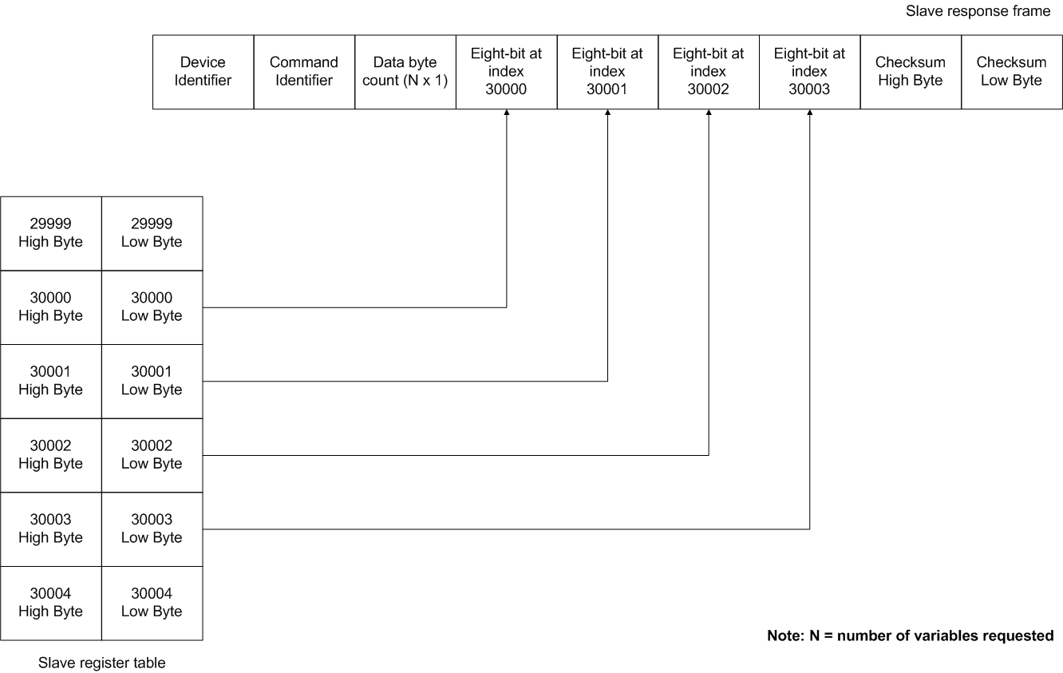
Figure 5 - Slave response to read eight-bit command for four variables from index 30000

Read sixteen-bit

Master request

The read sixteen-bit command allows one or more sixteen-bit values to be read from a slave device. It follows the same format as the read eight-bit command, as shown in Figure 4.

Slave response
The slave response to a read sixteen-bit command is similar to that of the format defined for the response to read eight-bit commands. Requested sixteen-bit variables are read from the register table and returned to the master device as shown in Figure 6.

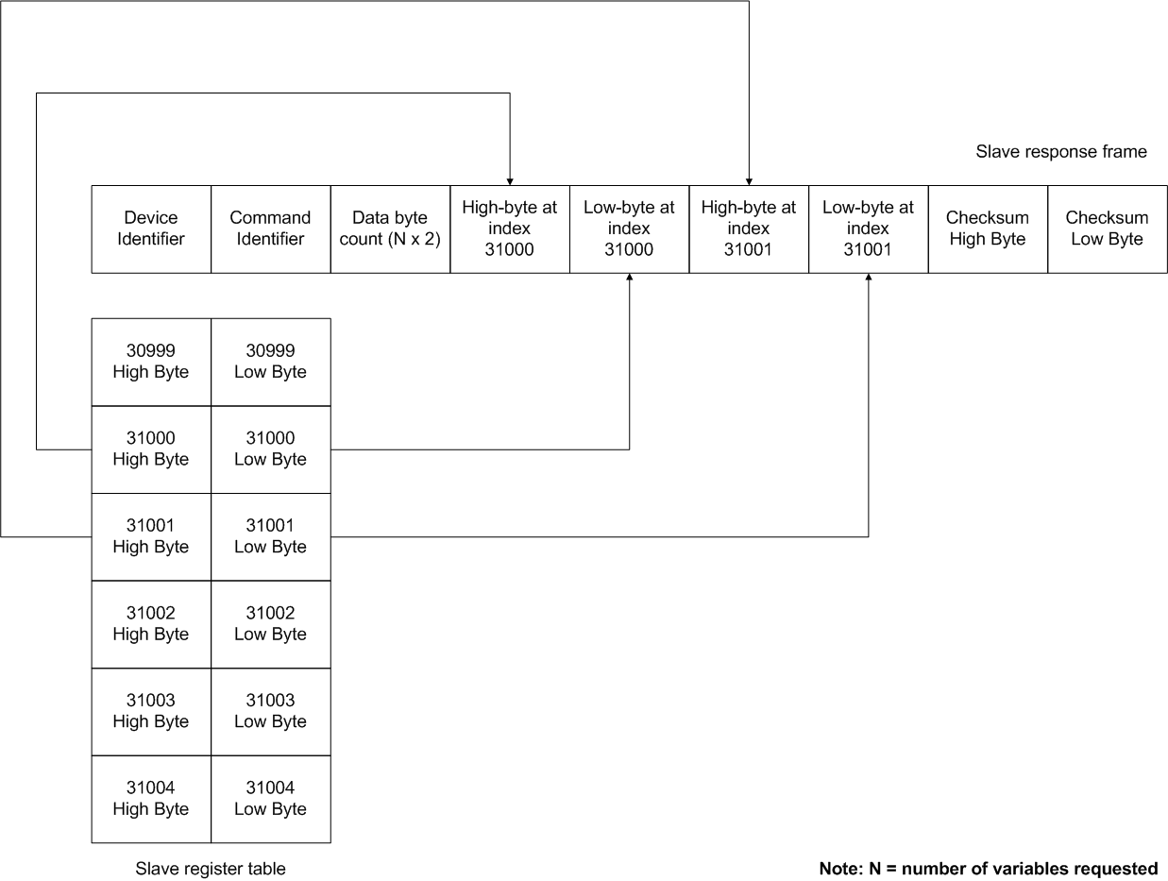
Figure 6 - Read sixteen-bit response to request to read two variables at index 31000

Read thirty-two-bit

Master request

This allows one or more thirty-two-bit variables to be read from the slave device. As shown in Figure 4, the device and command identifiers are followed by the two-byte starting register address, the two-byte number of variables to read, then the message checksum.

Slave response
For each thirty-two-bit variable requested, the slave returns the content of two registers from the register table. Refer to Figure 7 for further details.

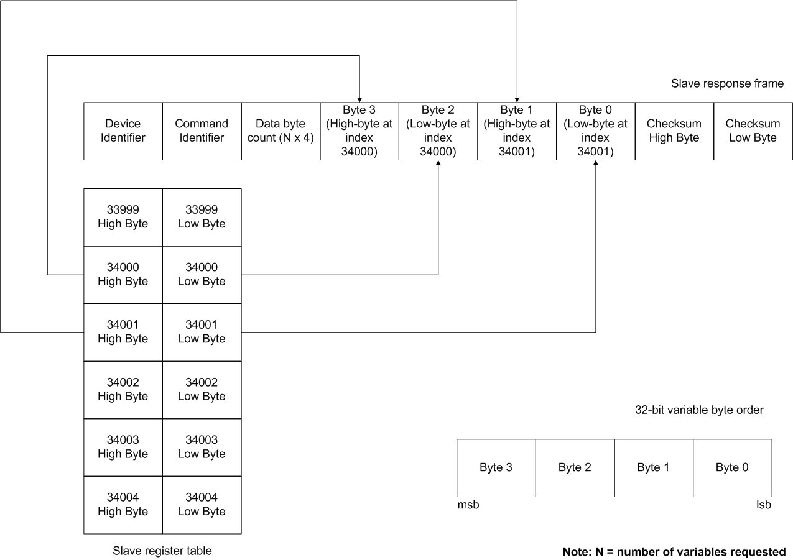
Figure 7 - Slave response to request to read one thirty-two-bit variable at index 34000

Read single-precision floating-point

Master request
The read single-precision floating-point command allows the master to read one or more single-precision floating-point variables from a slave device. It follows the general format for a custom read command shown in Figure 4.

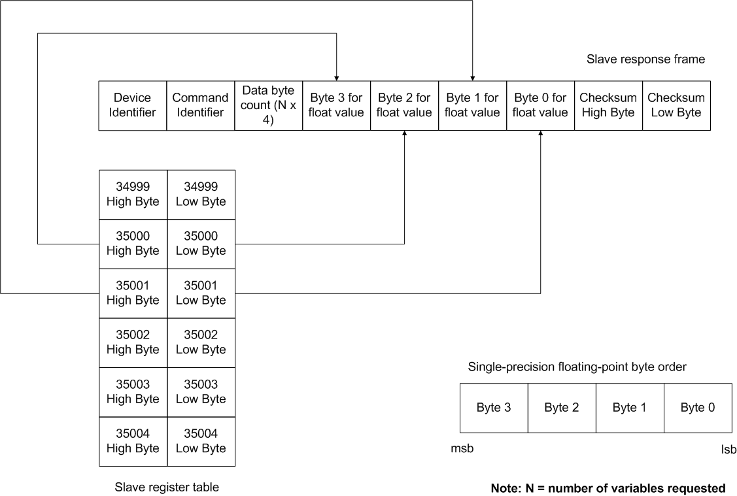
Figure 8 – Slave response to a read single-precision floating-point command

Slave response
Upon successful reception of a read single-precision floating-point command, the slave returns the requested data by reading two registers from the index table for each requested variable. Refer to Figure 8 for an example of a slave response to a read single-precision floating-point command.

Read double-precision floating-point

Master request
Masters can read one or more double-precision floating-point values with this command. The request is arranged as shown in Figure 4.
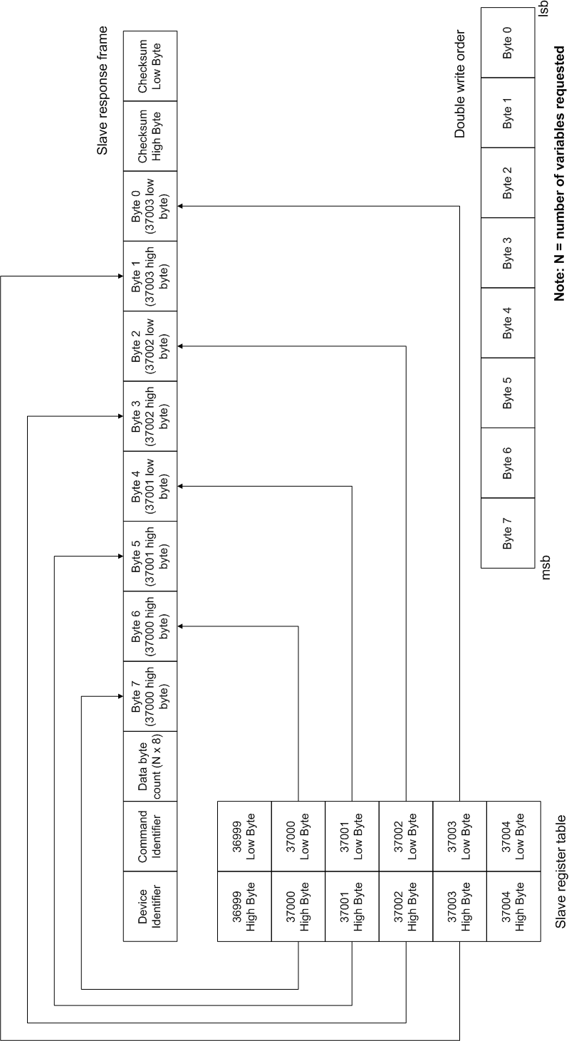
Figure 9 – Slave read double command response

Slave response
The slave response to this command follows the format for that for the other custom read commands. It differs only in that it returns the content of four registers for each double-precision floating-point value requested. Refer to Figure 9 for a slave response frame to a read double-precision floating-point request.

Read float with units
The read float with units command allows single-precision floating-point values and the associated units code to be read simultaneously.

Master request
Read float with units custom commands follow the general form of read commands as described in 4.1 and shown in Figure 4.

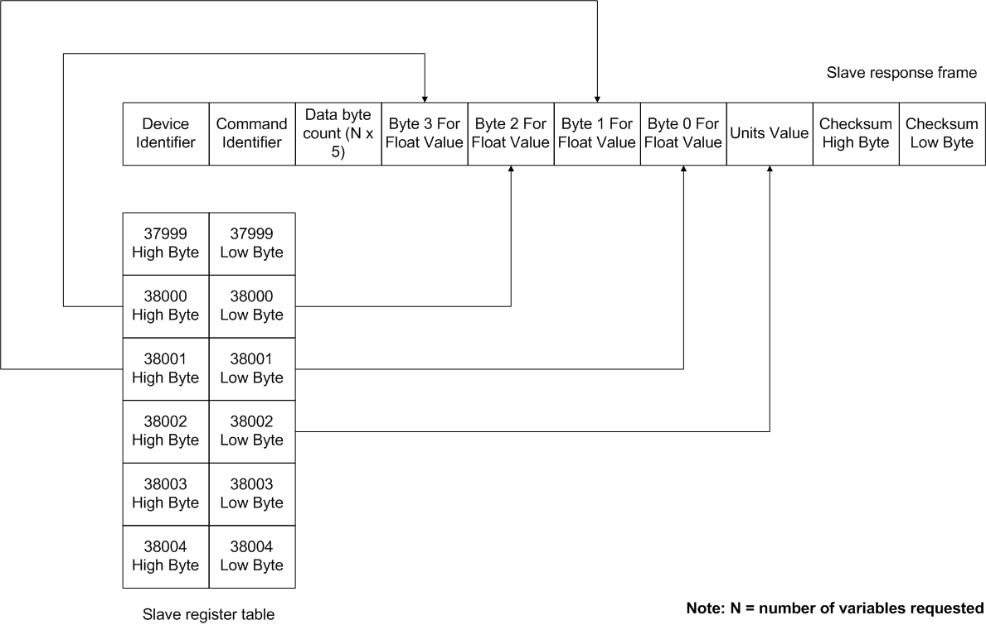
Figure 10 – Read float with units slave response

Slave response
The slave device responds to read float with units commands as shown in Figure 10. Each floating-point value is followed by the single byte units code for each variable read.

Read string

The read string command is used to read string data from a slave device. This command differs from the previously discussed commands in that the length of strings being read can vary. The master device still requests to read a number of string variables, but the returned length of data cannot be guaranteed to be the same when different strings are read. For this reason, the master must know the length of the strings being requested, and allocate enough storage space for the string data to be read into.

It should be noted that the read string command can only be used to read a whole string.

Master request

As with the other read commands, the master request consists of the register from where to start reading the string data and the number of string variables to read. Refer to Figure 4 for further details of the master request frame.

Slave response

The slave responds with the requested string data as shown in Figure 11. Two strings are being read in this example, the first four bytes long and the second six bytes long. As with the responses to the previously discussed read commands, the device and command identifier, then the number of data bytes being returned precede the response string data. The message checksum then follows.

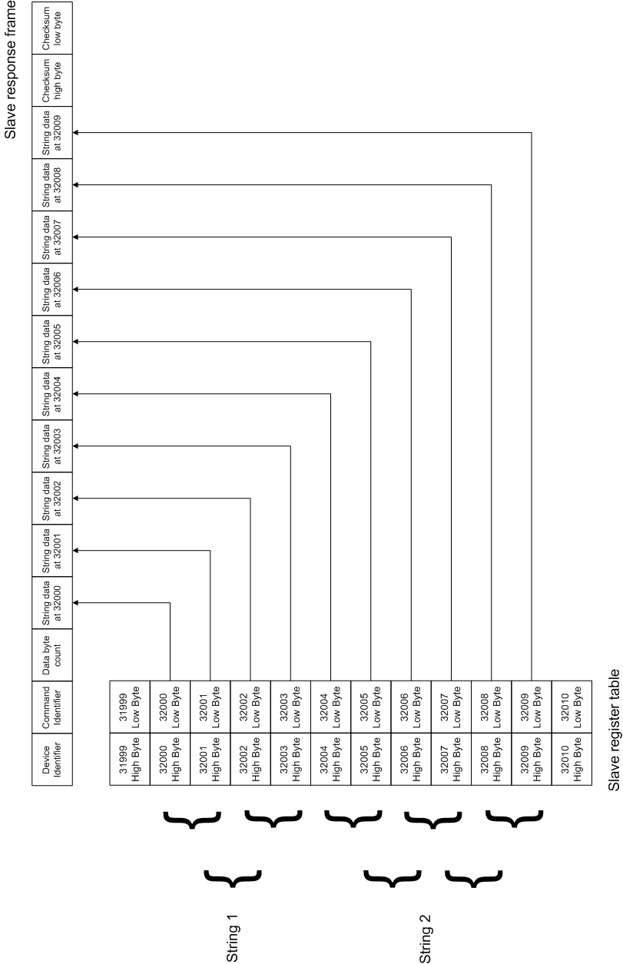

Figure 11 – Slave response to master read string request to read two strings

Read diagnostic information

This command is used to read the read-only extended diagnostic information associated with system alarms. Each diagnostic information block comprises of fourteen bytes, the structure of which is shown in Figure 12.

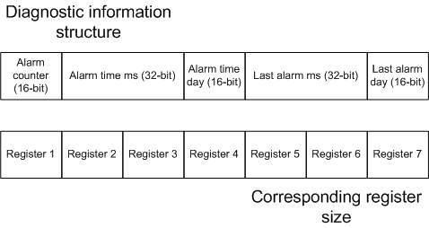
Figure 12 – Extended diagnostic information block

When this command is executed, each variable being read is fourteen bytes wide. There is no equivalent write command for diagnostic information.

Master request
A master request to read diagnostic information follows the format shown in Figure 4 – the master passes the start register of the initial diagnostic block to read, followed by the number of diagnostic blocks to be read.

Slave response
If valid command data is received by the slave device, the requested number of diagnostic information blocks are returned. The response follows the format of the previously discussed custom commands in that the data field is preceded by the device id, command identifier, requested start register, variable count (all sixteen-bits wide), then a data byte count (eight-bits wide) and followed by the sixteen-bit checksum of the message content.

Refer to Figure 13 for an example of a slave device response to a master request to read two diagnostic information blocks starting at register 39000.

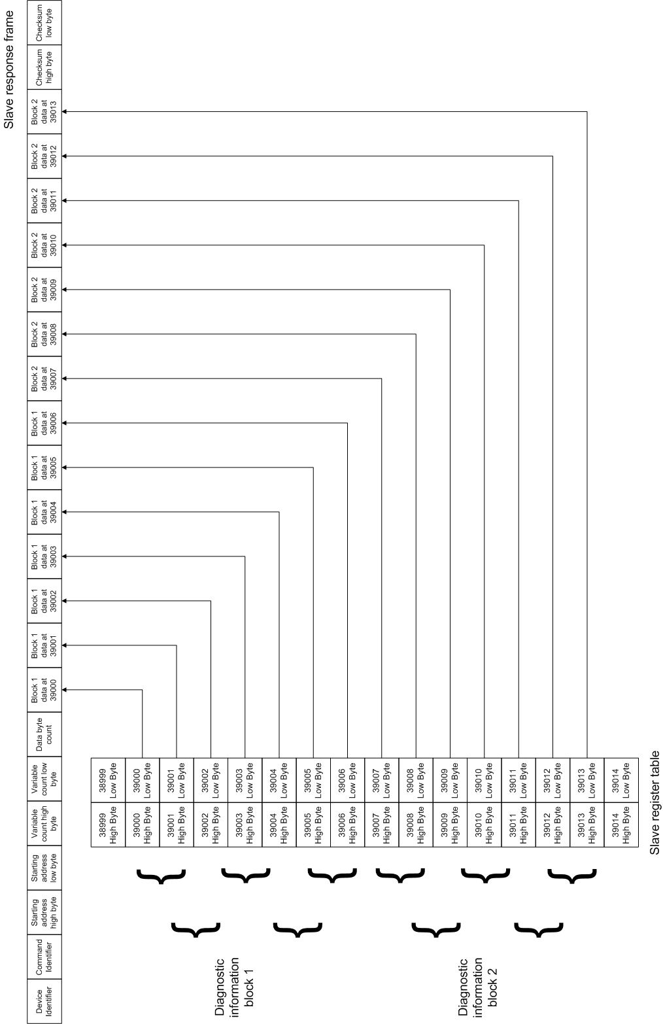
Figure 13 – Slave response to master request to read two diagnostic information blocks

Custom read command exception responses
Should any error checks fail during processing of the custom read commands, exception responses follow the format used by standard Modbus commands. The device identifier is sent as the first byte as usual. This is followed by the command identifier, which is binary ORed with the value 0x80 to signify an exception response. The actual exception code is then sent, followed by the two-byte message checksum.
No special exception codes are defined for the custom read commands; only the standard exception codes as defined in [2] are used. Figure 14 shows the format of Modbus exception response frames.

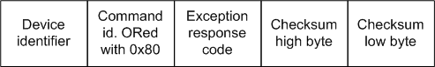
Figure 14 – Modbus exception response frame

Write commands
The general form of a master write request is shown in Figure 15. As with the custom read commands, the request frame is started with the device identifier, followed by the command identifier. Following the command identifier, the register address from where to start writing data is sent as two bytes. This is followed by the number of variables the master wishes to write, also sent as a sixteen-bit value.
A byte is then sent holding the number of data bytes to be written. This is followed by the actual data to be written to the variables. The length of this field depends on the value of the number of data bytes field, and the size of each variable being written.
The sixteen-bit CRC of the message is sent following the data bytes.
When multiple variables are being written, only the same type can be written, and the addresses at which they reside must be contiguous in the index table.

Figure 15 – General form of a master write request

Responses to write requests take the general form as shown in Figure 16. The slave device starts the frame by sending its device identifier, followed by the identifier of the command being responded to.

Figure 16 – Slave response to a successful master write request

The requested register address to start writing data from is added as two bytes, followed by the requested number of variables to be written, also as two bytes. The checksum of the message is then added as a two-byte value.

Write eight-bit

Master request
When requesting to write eight-bit data, the master device sends single bytes in the data byte field to the slave device. The number of data bytes field is set to the number of variables being written. Refer to Figure 17 for an example of a master write eight-bit request frame.

Slave response
After the slave device has validated the content of the request received from the master, it responds with the frame as shown in Figure 16.
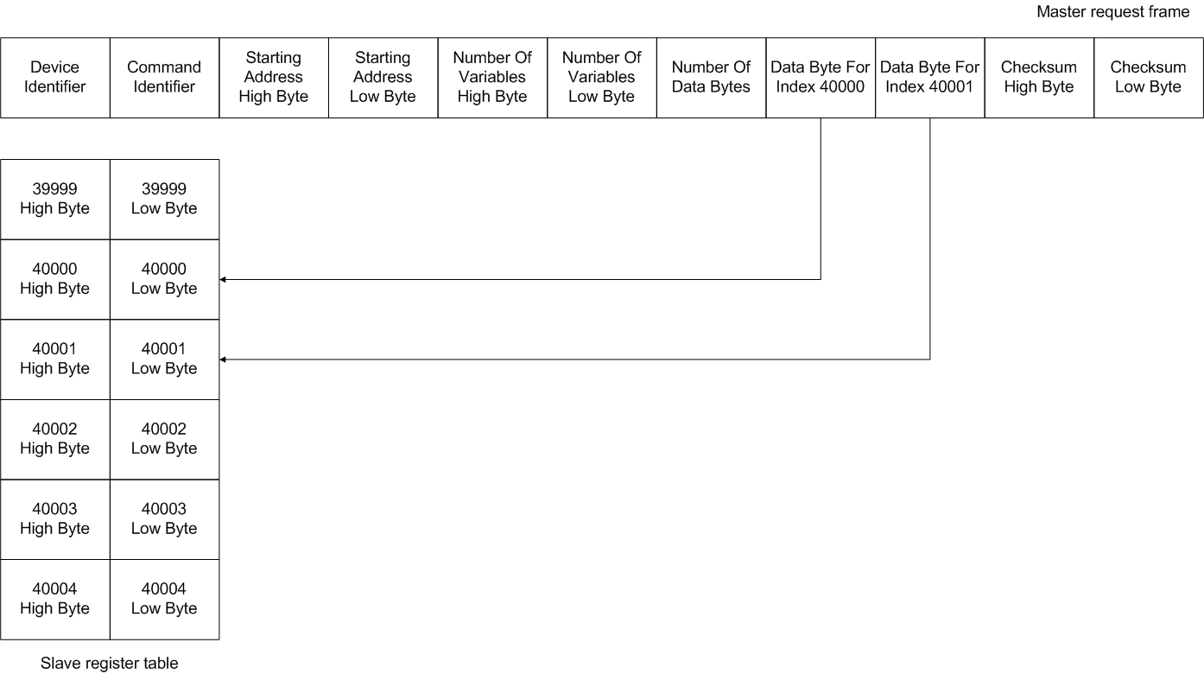
Figure 17 – Master request to write two eight-bit variables starting at location 40000

Write sixteen-bit

Master request
The master issues write sixteen-bit commands to write one or more sixteen-bit variables. A write sixteen-bit request follows the form shown in Figure 15. In this case data is sent as two-byte pairs for each variable to be written. Refer to Figure 18 for an example of a master write sixteen-bit request frame.

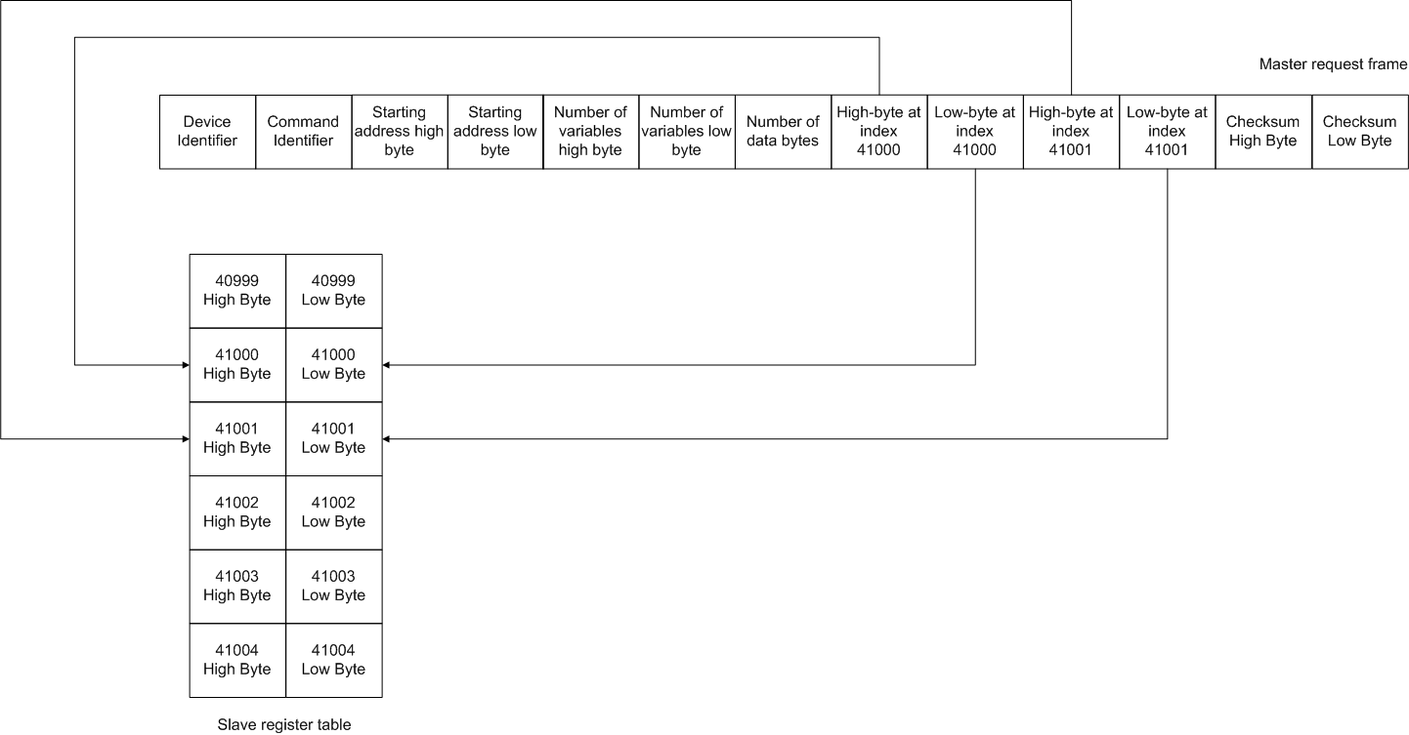
Figure 18 – Master request to write two sixteen-bit variables starting at index 41000

Slave response
The slave device responds to write sixteen-bit commands as it does to write eight-bit commands. Refer to Figure 16 for details of the slave response frame.

Write thirty-two-bit

Master request

One or more thirty-two-bit variables are written using this command. It follows the format of the previously defined write commands except that four bytes of data are sent for each variable to be written. Refer to Figure 19 for an example of a master write thirty-two-bit command request.

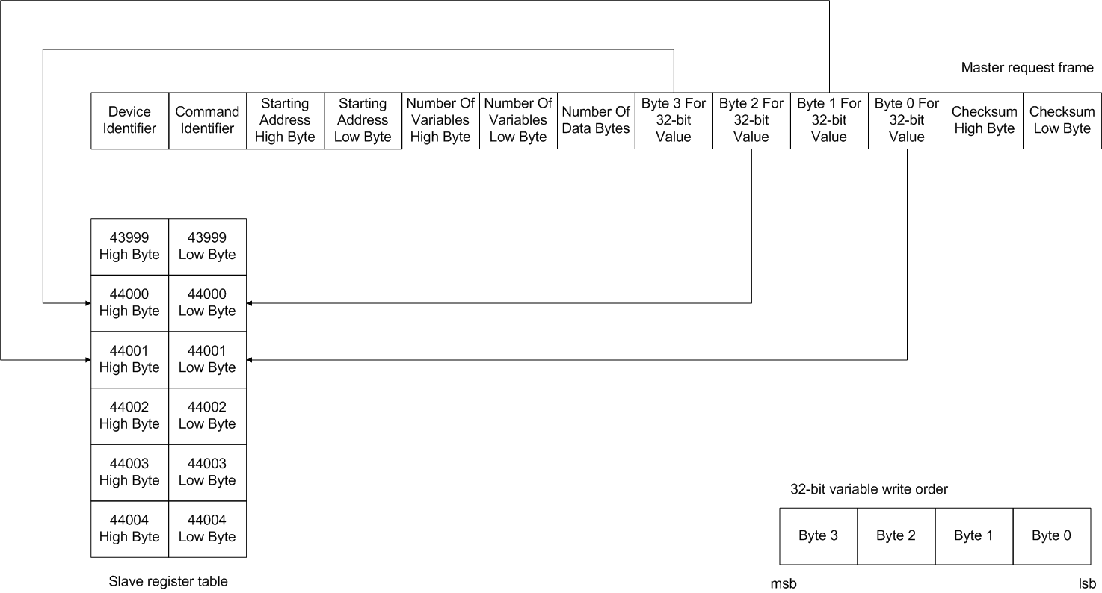
Figure 19 – Master write thirty-two-bit request to write one variable at index 44000

Slave response

Slave responses to write thirty-two-bit requests follow the format described in section 4.3 and shown in Figure 16.

Write single-precision floating-point

Master request

The master writes to one or more single-precision floating-point variables using this command. It follows the same format as the frame structure for the write thirty-two-bit command. A master request to write a single- precision floating-point variable is shown in Figure 20.

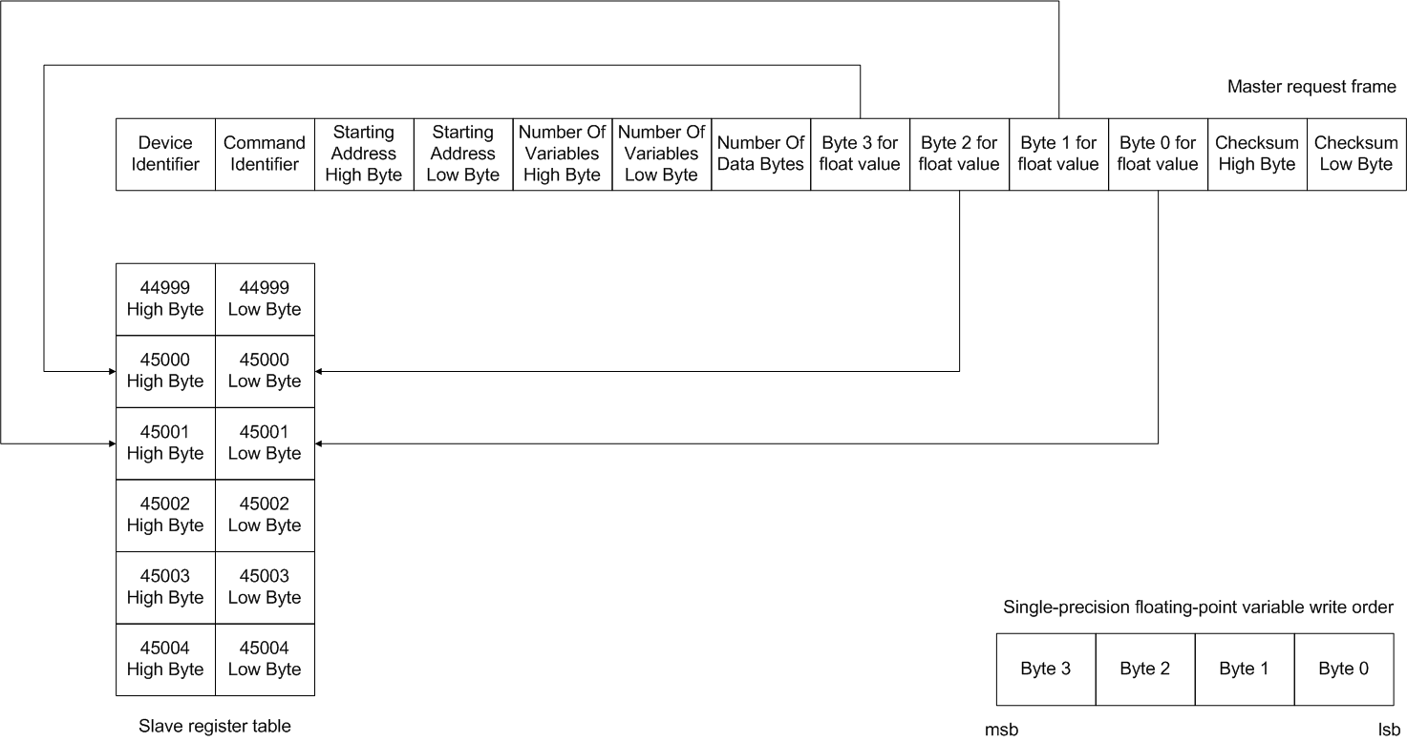

Figure 20 – Master request to write a single-precision floating-point value at index 45000

Slave response

Slaves respond to successfully completed write single-precision float commands as defined in 4.3 and shown in Figure 16.

Write double-precision floating-point

Master request

This command allows the master to write one or more double-precision floating-point values. It follows the same format as the other write commands, except data is sent in eight byte blocks for each variable to be written. Refer to Figure 21 for further details.
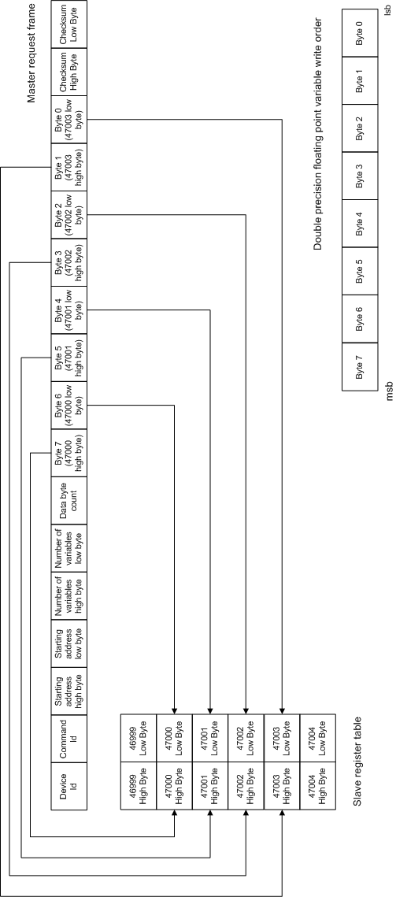

Figure 21 – Master double-precision float write request

Slave response

Slaves respond to successfully processed write double-precision floating-point values in the same format as described in section 4.3 and shown in Figure 16.

Write float with units

This command allows a master to write floating-point values with associated units simultaneously.

Master request

The unit code is an unsigned character and is sent following the four byte floating-point value. Padding is not required for the unit code. As with the previous custom write commands, the data to be written is preceded by the device identifier, the command identifier, the starting register address in two bytes, the number of variables being written in two bytes and the total number of data bytes being written. The data bytes are followed by the message checksum.

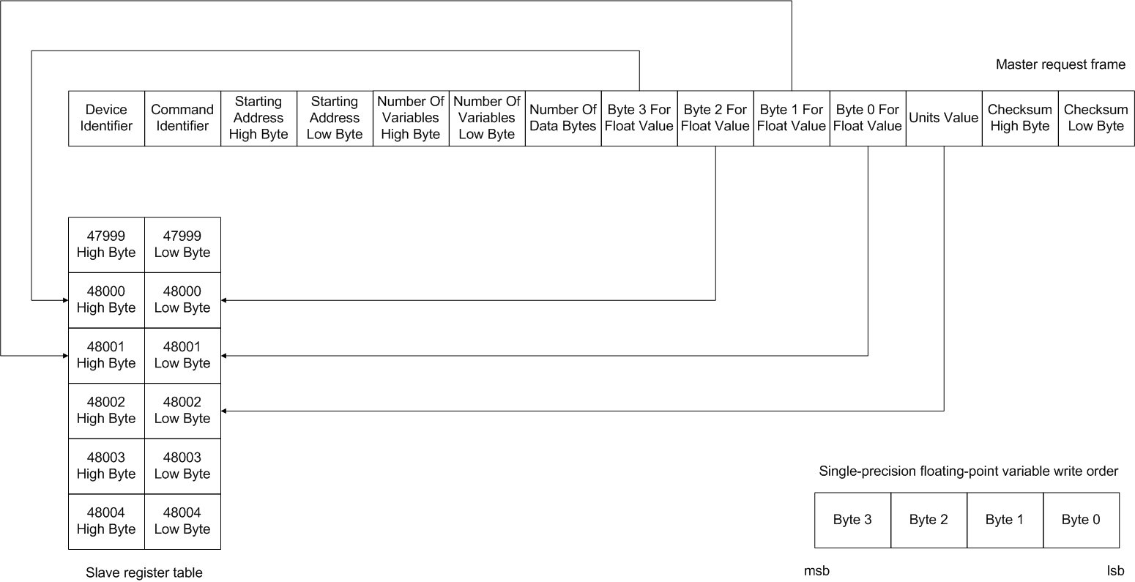

Figure 22 – Write float with units request

Slave response

The slave responds to successful write float with units commands as described in section 4.3 and shown in Figure 16.

Write string

String data is written by the master using the write string command. This command differs from the write commands previously discussed in that the length of string data is not consistent, and varies between string objects. Because of this, the master needs to know the length of the string objects being written.

As with the read string command, the write string command only allows whole strings to be written.

Master request

A string write request frame is shown in Figure 23. In this case, two strings of length four and six bytes are being written. The write string command follows the format of previously discussed write commands – refer to Figure 15 for details of the general format of custom write commands.

Slave response

Slave devices respond to successful string write commands as shown in Figure 16.

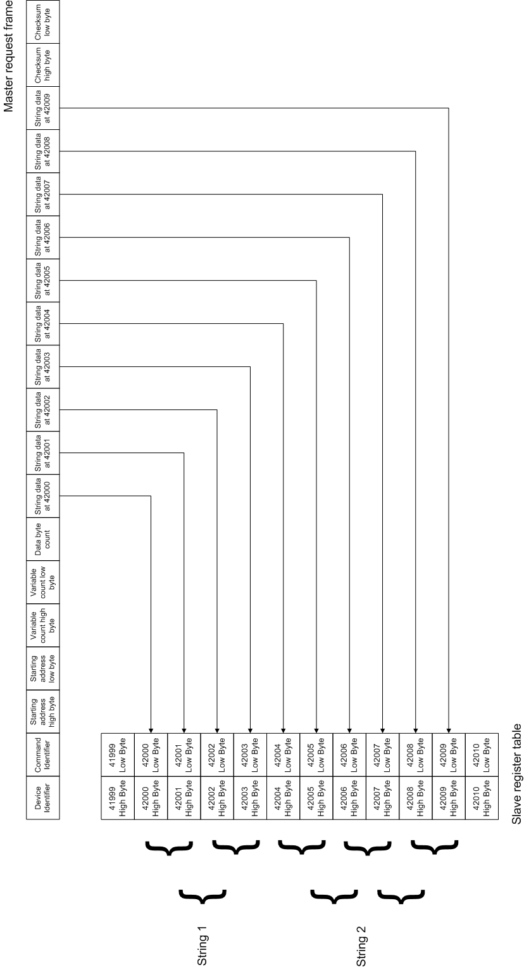

Figure 23 – Master write string request to write two strings

Trigger action function

This command is used to trigger action objects within the slave device. Action objects differ from other variables within the device in that they occupy no storage space; Rather they perform some action within the device when triggered (resetting a variable, changing state etc).

Master request
Master requests to trigger action objects differ from previously discussed write commands in that no data is required in the data field. Only the start register of the initial action object, and the number of action objects to trigger are contained within the data field. A master request frame is shown in Figure 24.

No corresponding command is available to read action objects.
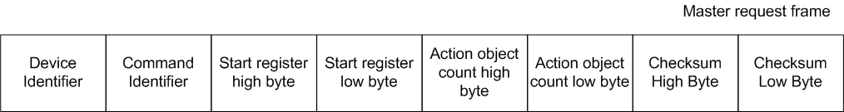

Figure 24 – Master request to trigger action objects

Slave response

If all action objects are triggered successfully, the slave device responds as to all other master write requests. Refer to Figure 16 for the slave response frame.

Custom write command exception responses

No special exception code responses are defined for the custom write commands. The general form as described in section 4.2 is followed.

References
Ref. | Document
[1] | Modicon Modbus Protocol Reference Guide  http://www.modbustools.com/PI_MBUS_300.pdf
[2] | Modbus Application Protocol  http://www.modbus.org/docs/Modbus_Application_Protocol_V1_1b.pdf
[3] | Controller Modbus Subsystem Requirements Specification
[4]
[5]

Revision History
Rev. | Description of Version/Changes | Primary Author(s) | Date
0.1 | Initial revision. | Greg Leach | 2008-07-15
0.2 | Changed index numbers to match those defined in Modbus subsystem requirements spec. | Greg Leach | 2008-07-16
0.3 | Added sections for read and write float with units commands.  Added total number of data-bytes to each read response from slave.  Added section on exception responses for custom read and write commands.  Added section detailing how non-register/coil data-types are distributed throughout the application variable table. | Greg Leach | 2008-08-29
0.4 | Added details of read and write string commands.  Updated read and write 32-bit diagrams to account for changes to register table layout in requirements document. | Greg Leach | 2008-09-10
0.5 | Added details of trigger action function command and read diagnostic information command. | Greg Leach | 2008-11-05

